**Assignment-3**

Cloudobjectstorage andWatsonassistant

|  |  |
| --- | --- |
| AssignmentDate | 17October2022 |
| StudentName | M. Maha Shree |
| StudentRollNumber | 951319104030 |
| MaximumMarks | 2 Marks |

**Question-1:**

CreateaBucket inIBMobjectstorage

**Solution:**

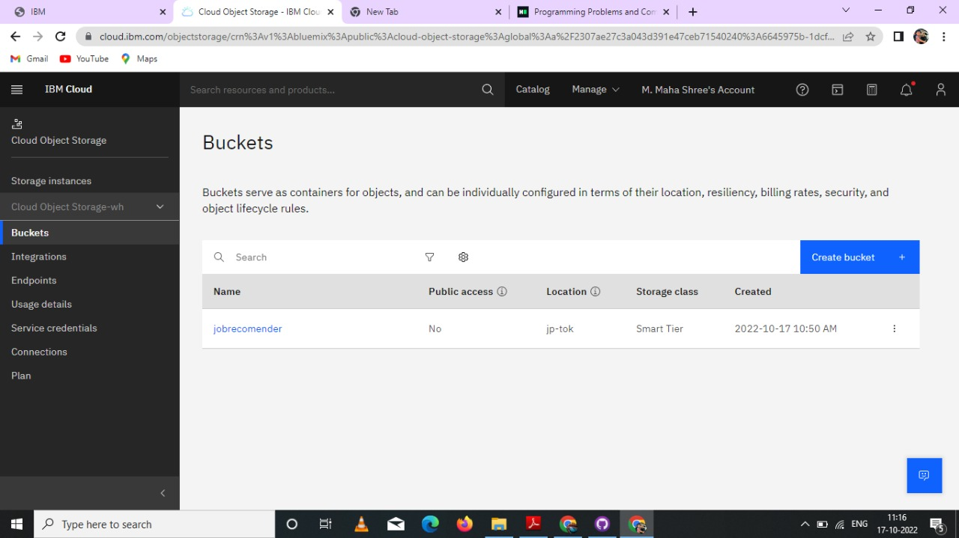

**Question-2:**

**Uploadan5 imagestoibmobjectstorageandmakeitpublic. Writehtmlcodetodisplayingallthe5images.**

**Solution:**

**Htmlcode:**

**<!DOCTYPE html>**

**<html>**

**<head>**

**<link rel="stylesheet" href="https://cloud-object-storage-er-cos-standard-1xw.s3.jp-tok.cloud-object-storage.appdomain.cloud/new.css">**

**</head>**

**<script>**

**window.watsonAssistantChatOptions = {**

**integrationID: "0b305951-d464-4f72-9cc7-938932287427", // The ID of this integration**

**region: "jp-tok", // The region your integration is hosted in.**

**serviceInstanceID: "c76a7424-a49e-4889-93f5-6b47b095e5f9", // The ID of your service instance.**

**onLoad: function(instance) { instance.render(); }**

**};**

**setTimeout(function(){**

**const t=document.createElement('script');**

**t.src="https://web-chat.global.assistant.watson.appdomain.cloud/versions/" + (window.watsonAssistantChatOptions.clientVersion || 'latest') + "/WatsonAssistantChatEntry.js";**

**document.head.appendChild(t);**

**});**

**</script>**

**<body>**

**<h1>This images are from the cloud object storage</h1>**

**<div class="grid-container">**

**<div class="item1"><img src="https://jobrecomender.s3.jp-tok.cloud-object-storage.appdomain.cloud/1.software.jpg"></div>**

**<div class="item2"><img src="https://jobrecomender.s3.jp-tok.cloud-object-storage.appdomain.cloud/2.coding.jpg"></div>**

**<div class="item3"><img src="https://jobrecomender.s3.jp-tok.cloud-object-storage.appdomain.cloud/3.internet.jpg"></div>**

**<div class="item4"><img src="https://jobrecomender.s3.jp-tok.cloud-object-storage.appdomain.cloud/4.engineer.jfif"></div>**

**<div class="item5"><img src="https://jobrecomender.s3.jp-tok.cloud-object-storage.appdomain.cloud/5.coder.jfif"></div>**

**</div>**

**</body>**

**</html>**

**Output:**

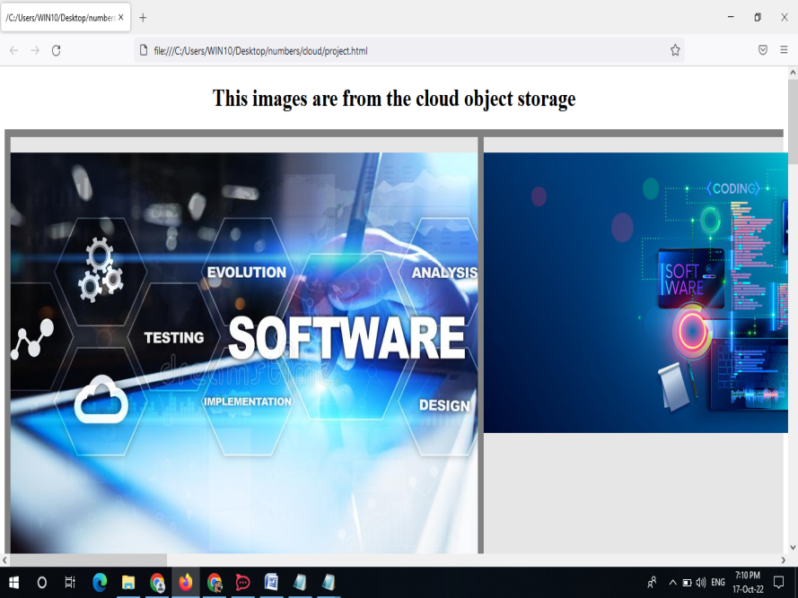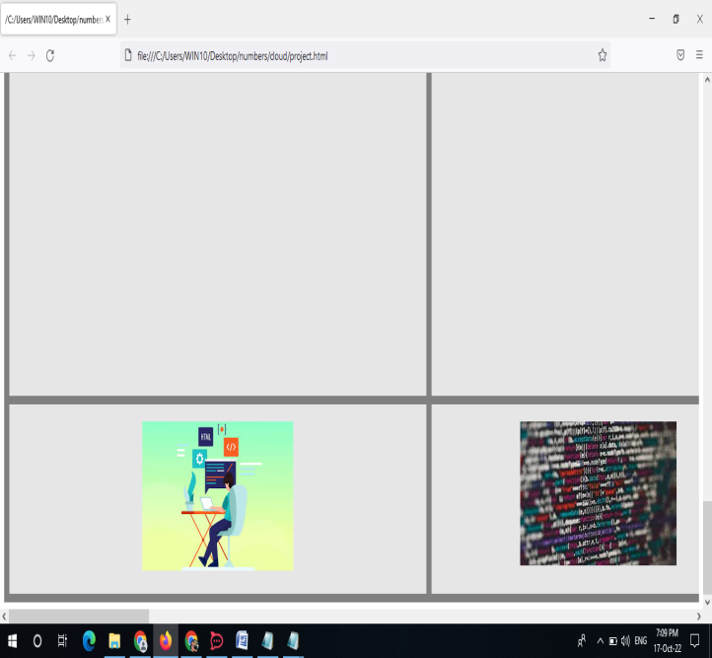

**Question-3:**

Upload a css page to the object storage and use the same page in your html code.Solution:

New.cssuploadedtotheobjectstorage andusedthesamepage inhtmlcode

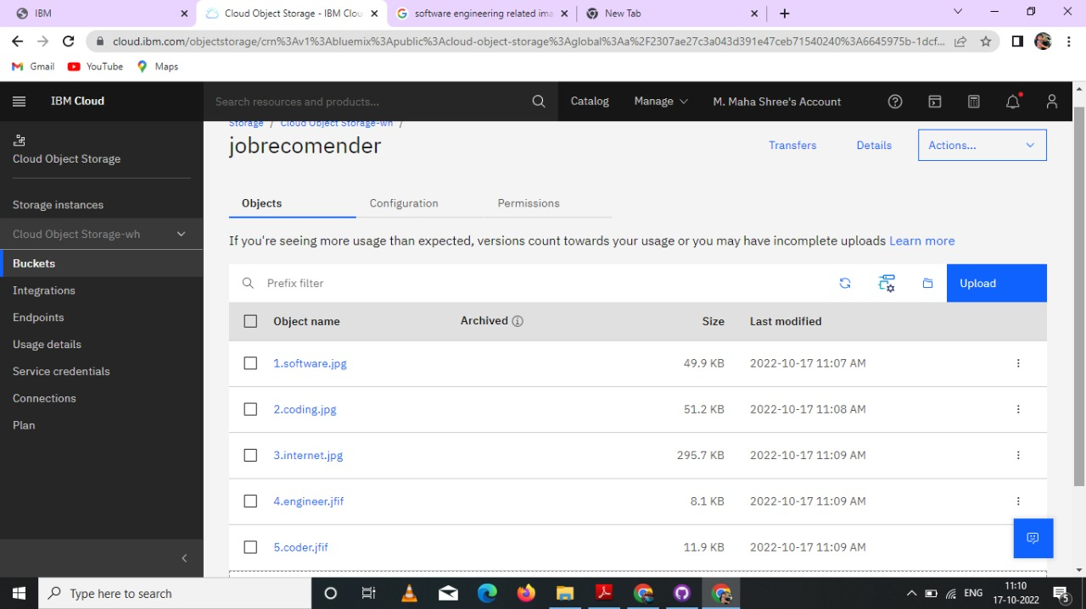

Csspage usedinhtmlpage



**Question-4:**

Design a Chabot using IBM Watson assistant for hospital. Ex: User come the query to know the braches for thathospital inyourcity.

Solution:

URL for: <https://web-chat.global.assistant.watson.appdomain.cloud/preview.html?backgroundImageURL=https%3A%2F%2Fau-syd.assistant.watson.cloud.ibm.com%2Fpublic%2Fimages%2Fupx-6206aee1-b8f2-41cb-a67f-f371431e0710%3A%3A4a2bdd73-15af-4c2f-8983-ba02d7b177e3&integrationID=9591cce0-d0e4-4573-a279-8ac556ec519f&region=au-syd&serviceInstanceID=6206aee1-b8f2-41cb-a67f-f371431e0710>

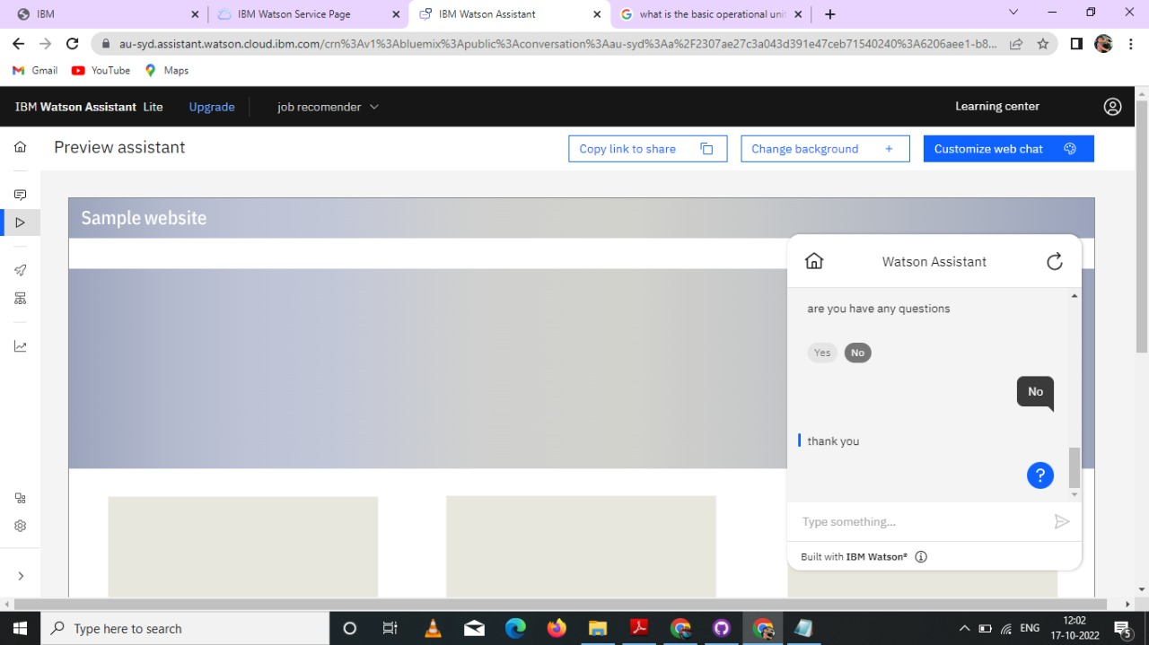

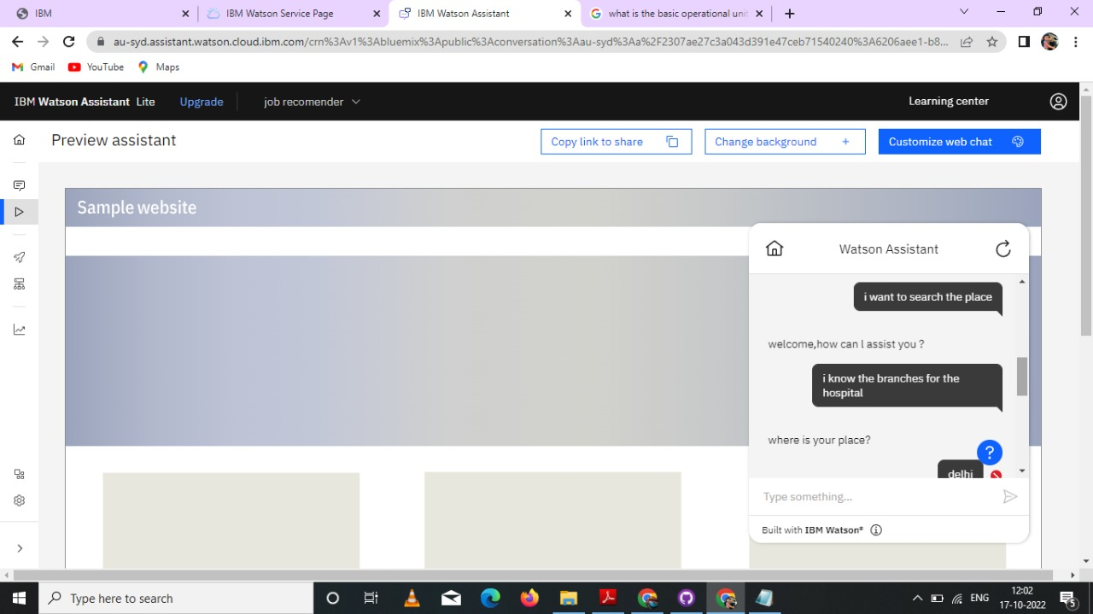

**Question-5:**

Create Watson assistant service with 10 steps and use 3 conditions in it. Load that script in html pageSolution:

<!DOCTYPE html>

<html>

<head>

<link rel="stylesheet" href="https://cloud-object-storage-er-cos-standard-1xw.s3.jp-tok.cloud-object-storage.appdomain.cloud/new.css">

</head>

<script>

window.watsonAssistantChatOptions = {

integrationID: "0b305951-d464-4f72-9cc7-938932287427", // The ID of this integration

region: "jp-tok", // The region your integration is hosted in.

serviceInstanceID: "c76a7424-a49e-4889-93f5-6b47b095e5f9", // The ID of your service instance.

onLoad: function(instance) { instance.render(); }

};

setTimeout(function(){

const t=document.createElement('script');

t.src="https://web-chat.global.assistant.watson.appdomain.cloud/versions/" + (window.watsonAssistantChatOptions.clientVersion || 'latest') + "/WatsonAssistantChatEntry.js";

document.head.appendChild(t);

});

</script>

<body>

<h1>This images are from the cloud object storage</h1>

<div class="grid-container">

<div class="item1"><img src="https://jobrecomender.s3.jp-tok.cloud-object-storage.appdomain.cloud/1.software.jpg"></div>

<div class="item2"><img src="https://jobrecomender.s3.jp-tok.cloud-object-storage.appdomain.cloud/2.coding.jpg"></div>

<div class="item3"><img src="https://jobrecomender.s3.jp-tok.cloud-object-storage.appdomain.cloud/3.internet.jpg"></div>

<div class="item4"><img src="https://jobrecomender.s3.jp-tok.cloud-object-storage.appdomain.cloud/4.engineer.jfif"></div>

<div class="item5"><img src="https://jobrecomender.s3.jp-tok.cloud-object-storage.appdomain.cloud/5.coder.jfif"></div>

</div>

</body>

</html>

Output:

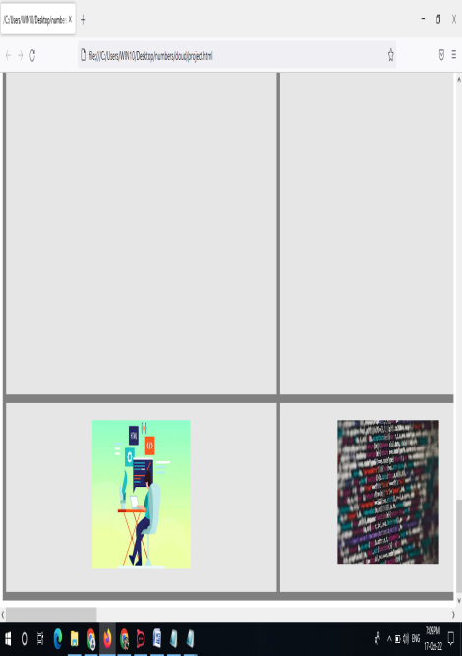

URL for chatbot : <https://web-chat.global.assistant.watson.appdomain.cloud/preview.html?backgroundImageURL=https%3A%2F%2Fau-syd.assistant.watson.cloud.ibm.com%2Fpublic%2Fimages%2Fupx-603018e1-4996-4dd4-86dc-95e357de29a9%3A%3A29317ed0-110b-4647-9ef9-8c35990db395&integrationID=78131e16-1956-4b2c-b782-e5d398675a0b&>region=au-syd&serviceInstanceID=603018e1-4996-4dd4-86dc-95e357de29a9

URL for webpage: <https://api.au-syd.assistant.watson.cloud.ibm.com/instances/603018e1-4996-4dd4-86dc-95e357de29a9>